12/09/25

# Power Bi Dashboard

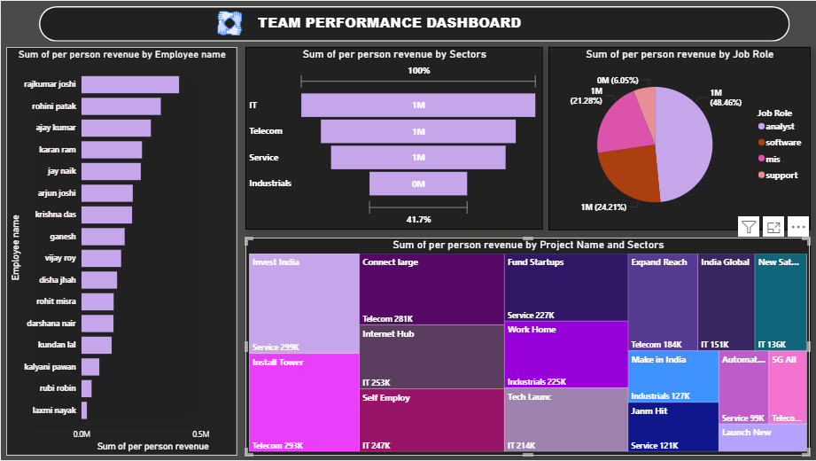

Using Performance Details.

Create a shape for heading and named at team performance dashboard.

1.To create a **stacked Bar chart:**

1. go to **Visualizations** and select the stacked Bar chart.
2. On the **Y-axis**, place the **Employee name** field.
3. On the **X-axis**, place the **Per person unit** field.
   * It will automatically change to **Sum of Per person unit**.
4. Change color for bar and chart effects.
5. Add a color for background.
6. Change color for font.

2.To create a **stacked Funnel:**

1. go to **Visualizations** and select the stacked Bar chart.
2. On the **Category**, place the **Sectors** field.
3. On the **Values**, place the **Per person unit** field.
   * It will automatically change to **Sum of Per person unit**.
4. Change color for bar and chart effects.
5. Add a color for background.
6. Change color for font.

3.To create a **stacked Pie chart:**

1. go to **Visualizations** and select the stacked Pie chart.
2. On the **Legend**, place the **Job role** field.
3. On the **Values**, place the **Per person unit** field.
   * It will automatically change to **Sum of Per person unit**.
4. Change color for pie and chart effects.
5. Add a color for background.
6. Change color for font.

4.To create a **Treemap:**

1. go to **Visualizations** and select the Treemap.
2. On the **Category**, place the **Employee name** field.
3. On the **Details**, place the **Sectors** field.
4. On the **Values**, place the **Per person unit** field.
   * It will automatically change to **Sum of Per person unit**.
5. Change color and chart effects.
6. Add a color for background.
7. Change color for font.